**Bonus Part**

Date: October 4th 2017

Group Member:

1. Sanket Achari, UFID: 71096329
2. Sushmit Dharurkar, UFID: 14969578

We have implemented node and failure model for **gossip algorithm.**

Our implementation is based on the comparison of spread of rumor in 5 seconds for each topology. We have calculated the percentage spread i.e.

% Spread = Rumor received by number of nodes / Total Nodes.

For the results included in this report, we considered 3 cases of failure nodes.

1. No failure
2. 10% failed nodes
3. 20% failed nodes

Each topology has been compared for these 3 types of failure conditions.

Our key observations:

1. For line topology, failure of nodes significantly reduces the spread of rumor. That means rumor doesn’t get spread to active nodes due to the presence of failed i.e. disconnected nodes.   
   **Less than 10% of nodes got the rumor in case of 10% and 20% failed nodes**
2. In case of full, 2D and Imperfect 2D, rumor spread was better as, except disconnected nodes, almost all other nodes received the rumor.

**More than 90% of alive nodes heard the rumor even though few nodes were disconnected for full, 2D and Imperfect 2D topologies**

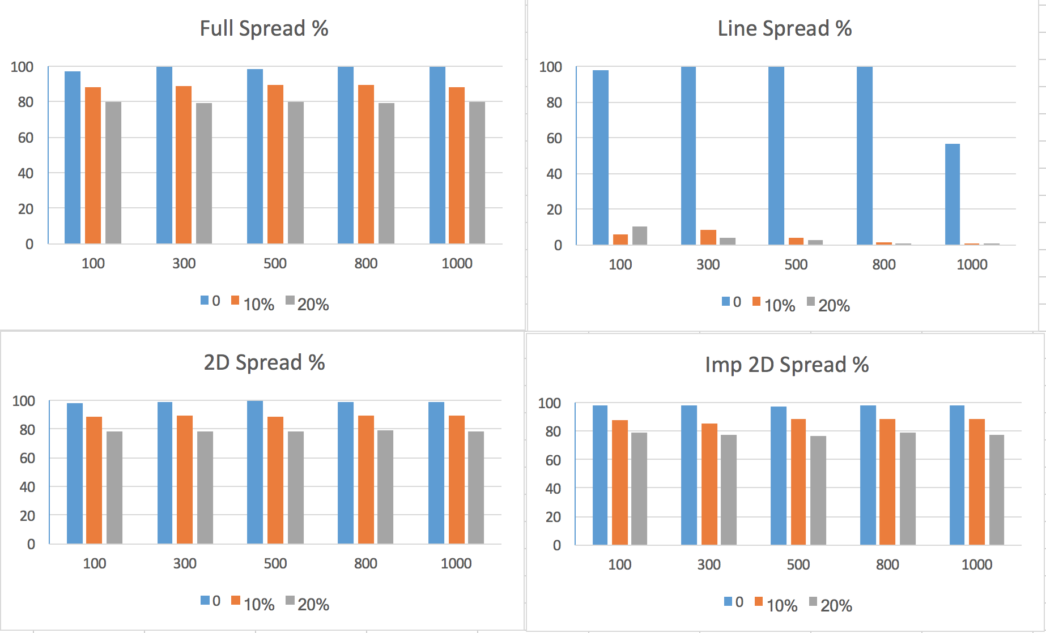

**Fig1: Percentage spread in 5 seconds for 100, 300, 500, 800, 1000 nodes for all topologies**

**Run Instructions:**

1. cd project2-bonus && mix escript.build
2. ./project2 100 full gossip 10

100: Number of nodes

full: Topology

gossip: Algorithm

10: % of failed nodes (Has to be integer)

More examples:

./project2 800 2D gossip 20

./project2 1000 line gossip 0